Financial Lit Name: _______________________

______________ _____________

WS Assessment

Target 10:

Buy or sell a car

**I can:**

* Compute the cost of classified ads for used car
* Compute mean, median, mode, range, quartiles and IQR
* Create a frequency distribution from a set of data.

**Unit 5 Math Topics:**

* Circles (radius, diameter, chord)
* Distance Formula
* Exponential growth and decay
* Linear equations and inequalities
* Linear and exponential functions
* Measures of central tendency
* Metric System
* Natural logarithm
* Percent and Proportions
* Piecewise functions
* Range
* Read and interpret data: frequency tables, stem-and-leaf plots, box plots
* Quartiles
* Straight line equations (depreciation)
* Slope, slope-intercept form
* Square root equations
* Spreadsheets and formulas
* Systems of linear equations and inequalities in two variables

Most teenagers cannot wait to get their own set of “wheels.” New cars are expensive, so many people buy used cars when they purchase their first car. They can buy used cars from a dealer or by looking at the classified ads in the newspaper or on the Internet.

Jason works for the Glen Oaks News and is writing a program to compute ad costs. He needs to enter an algebraic representation of the costs of an ad. His company charges $42.50 for up to five lines for a classified ad. Each additional line costs $7. Express the cost of an ad with x lines as a function of x algebraically.

The Smithtown News charges $38 for a classified ad that is 4 or fewer lines long. Each line above four lines costs an additional $6.25. Express the cost of an ad as a piecewise function.

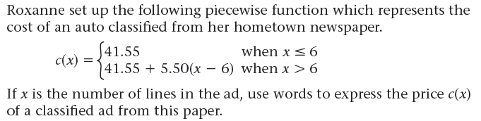

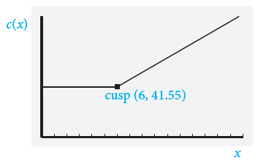

Re-create this graph on desmos for stamp

A local newspaper charges by the character for its classified ads. Letters, numbers, spaces, and punctuation each count as one character. They charge $46 for the first 200 characters and $0.15 for each additional character.

a. If x represents the number of characters in the ad, express the cost c(x) of an ad as a piecewise function. b. Graph the function from part a. (Stamp) c. Find the coordinates of the cusp in the graph in part b.

The Kelley Blue Book (www.kbb.com) and Edmunds (edmunds.com) are two of many excellent sources on the Internet you can use to find the value of a used car.

As you search, compile a list of advertised prices for the cars you want. Then, you can use **statistics** to

help analyze the numbers, or **data**, that you compile. **Measures of central tendency** are single numbers designed to represent a ‘typical’ value for the data.

Jason wants to sell his Ford SUV. He compiles these prices from the Internet for cars similar to his: $11,000, $9,900, $12,100, $10,500, and $9,000. What is a reasonable price for Jason to consider for his SUV? (Mean or arithmetic average)

Dory is looking for a classic 1967 Firebird. She finds these prices on the Internet: $18000, $77000, $22000, $21200, $19000, $17500, and $22500. She computes the mean as? ____________

This number doesn’t seem to be a good representative of the data. How can she find a better representation?

There is an **outlier** - a piece of data that is extremely different than the rest of the data. When there are outliers, the mean is often not a good representation. In these cases, you can use the **median** - the middle score - to best represent the data. What is the median?

When the mean of a data set is not equal to the median, the data is **skewed**.

If you want to find out more about how the numbers are dispersed, you can use **quartiles**. Quartiles are three values represented by Q1, Q2, and Q3 that divide the distribution into four subsets that each contain 25% of the data. The difference Q3 − Q1 is the interquartile range (IQR). The interquartile range gives the range of the middle 50% of the numbers.

Find the IQR of the Dory’s data above

The following list of prices is for a used original radio for a 1955 Thunderbird. The prices vary depending on the condition of the radio.

$210, $210, $320, $200, $300, $10, $340, $300, $245, $325, $700, $250, $240, $200 Find

the mean of the radio prices? the median? Is this data skewed?

the mode of the radio prices? four quartiles?

find the interquartile range?

find the boundary for the **lower outliers Q1 – 1.5IQR**

Are there any lower outliers?

find the boundary for the **upper outliers. Q3 + 1.5IQR**

Are there any upper outliers?

Create a list of five different numbers whose mean is 50.

Create a list of six different numbers whose median is 10.

Create a list of five numbers whose mean and median are both 12.

Create a list of numbers whose mean, median, and mode are all 10.

Organize data using a table and graphs to display how the data is distributed

Jerry wants to purchase a car stereo. He found 33 ads for the stereo he wants and arranged the prices in ascending order:

$540 $550 $550 $550 $550 $600 $600 $600 $675 $700 $700 $700 $700 $700 $700 $700 $750 $775 $775 $800 $870 $900 $900 $990 $990 $990 $990 $990 $990 $1,000 $1,200 $1,200 $1,200

Set up a frequency distribution table in spreadsheet, stamp Hint: desmos (dotplot)

|  |  |  |  |  |  |  |  |  |  |  |  |  |  |
| --- | --- | --- | --- | --- | --- | --- | --- | --- | --- | --- | --- | --- | --- |
| Price P | $540 | $550 | $600 | $675 | $700 | $750 | $775 | $800 | $870 | $900 | $990 | $1,000 | $1,200 |
| Frequency f |  |  |  |  |  |  |  |  |  |  |  |  |  |

Then find the mean (sumproduct) median (cumulative frequency) and interquartile

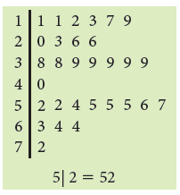

Stem and leaf plot

Find the mean and median and interquartile

Create a boxplot for the above data

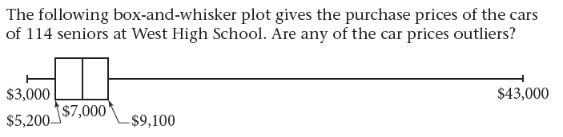

If you want to show outliers on a boxplot, you can create a modified boxplot. A modified boxplot shows all the numbers that are outliers as single points past the whiskers.

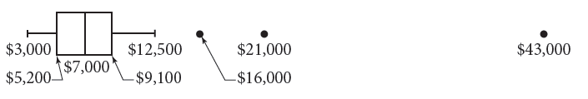

Brian looked up prices of thirteen used Chevrolet HHR ‘retro’ trucks in the classified ads and found these prices: $8500, $8500, $8500, $9900, $10800, $10800, $11000, $12500, $12500, $13000,

$13000, $14500, and $23000.

a. Make a frequency table for this data set.

b. Find the mean, median, Find the mode, range.

c. Find the four quartiles, the interquartile range.

d. Find the boundary for the upper outliers, the lower outliers.

e. How many outliers are there? Draw a modified box-and-whisker plot. Label it.

**Assessment Target 10**

**I can…** do statistical graphs

A local Pennysaver charges $11 for each of the first three lines of a classified ad, and $5 for each additional line.

a. What is the price of a two-line ad? the price of a five-line ad?

b. If x is the number of lines in the ad, express the cost c(x) of the ad as a piecewise function. Sketch and show for stamp.

Dan’s parents are going to pay for half of his car if he gets a 90 average in math for all four marking periods and the final exam. Here are his grades for the first four quarters: 91, 82, 90, and 89. What grade does he need on his final exam to have a 90 average?

The Cold Spring High School student government polled randomly selected seniors and asked them how much money they spent on gas in the last week. The following stem-and-leaf plot shows the data

they collected.

a. How many students were polled?

b. Find the mean to the nearest cent, the median, the mode, the range.

c. Find the four quartiles, the interquartile range

d. What percent of the students spent $53 or more on gas?

from $53 to $75 on gas?

e. Find the boundary for the lower outliers, the upper outliers.

f. How many outliers are there? Draw a modified boxplot.